How to access SVN Server (repository)

Jump to:

Checking out from Server(Linking to Server)

Adding files to repository (Upload to Server)

Upload changes to Server

Update from Server(Update Local copy)

**Checking out from Server (Linking to server)**

1. Go <http://tortoisesvn.net/downloads.html> and download the current version fit for your system (32 or 64 bit).   
   After downloading tortoiseSVN, install it in your PC and use default settings.

After install, restart the PC if necessary to apply changes.

1. After install (and PC restart). Create a folder at your desired location, this will be your workspace folder and it will be linked to the server. Named the folder as **“PopcakeLegend”.**
2. Go inside the folder you just created, Press mouse right click and choose SVN Checkout:

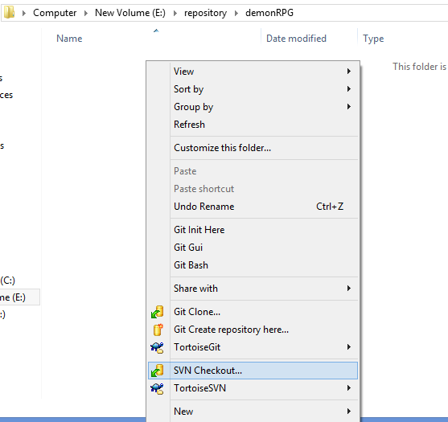

1. In the SVN Checkout Pop-up window input the following values:  
   URL of repository: <https://drulz.svn.cloudforge.com/popcakelegend>

Checkout Directory: The directory location of your folder

When Done, Press OK. Wait until download and link is complete.

You might need to log-in if required. Use your user name and password provided to you by administrator.  
  
YOUR ACCOUNT:  
username: hiba_tariq

Password: popcake123

1. Once the checkout is complete. Your folder is now linked to the server. You can verify this by checking the folder and it contains a hidden folder named “.svn”

You can also see the available folders found in the server.

Your new folder will now looked like the one bellow:

You are now ready to use the Server!!

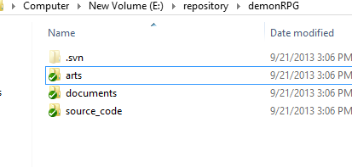

**Adding files to repository (Upload)**

**NOTE: Similar steps to perform when adding(uploading) files or folder to the server.**

1. Place your files in the desired folder that you like.

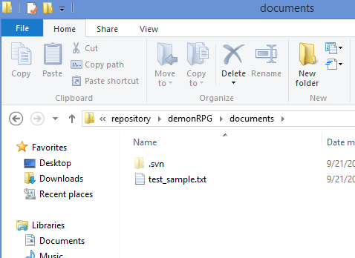

1. Go back to the top of the workspace directory (**demonRPG**), press mouse right click and select SVN Commit. An SVN commit window will appear.

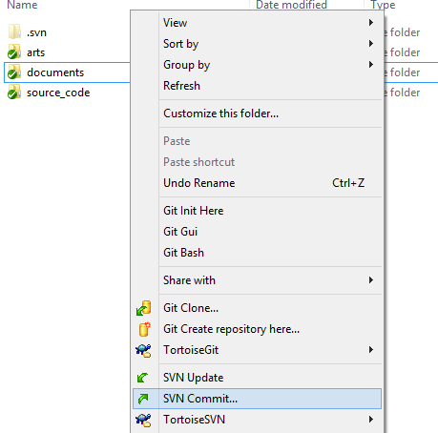

1. On the SVN Commit window, **select** the file you want to Upload ONLY. **Also it is important to leave message for the others to know the purpose of the file in the server**. Press OK when ready. Wait until Upload is complete.

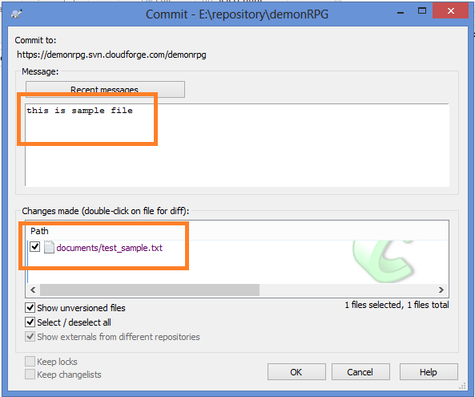

1. Once the upload is complete, you can see the uploaded files with a **check mark** on it.

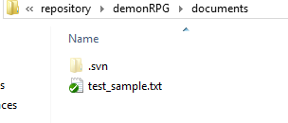

**Modifying files to repository (Upload changes)**

Since the files in your LOCAL copy are linked and connected to the server, you can edit the files in your local directory and apply the changes to the server, by doing the following steps.  
  
For example: the file sample_file.txt has been modified in my local machine, the file will appear with a red exclamation mark on it similar to bellow (instead of a green check mark).

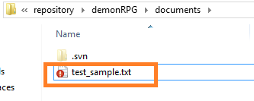

Once you are done with the desired changes you want and you want to REFLECT your changes to the server, You can upload the changes to your file by doing “SVN commit” on that file similar to uploading the files.  
  
1. Select the modified files, right click on it and choose “SVN Commit”. 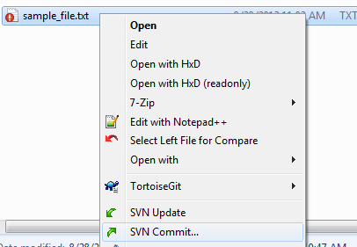

2. In the commit window, add the reason of the modification on the Messages field and click OK. Wait for it to complete the upload.

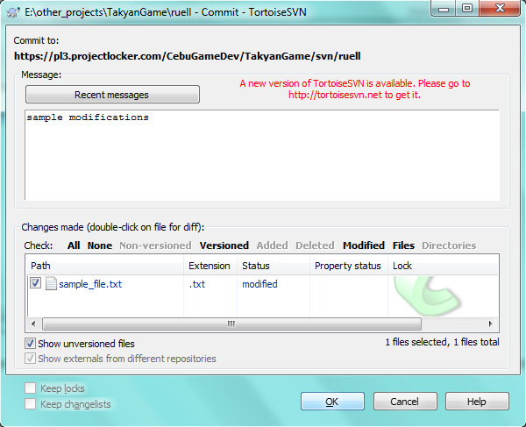

Once done, the files will be marked with a green check mark, which means that the file is updated in both your local copy and in the server.

**Updating from Server (Update Local copy)**

From time to time you want to update your local copy to reflect changes uploaded from other members of the team.

To do this, go to your workspace folder (or any folder you want to update), right click on it and choose “SVN Update”. Wait for the Update to complete. The list of the modified files will be listed on a pop-up window while the update is downloading.

